Catrina Hill

Exhibition Assistant Curator

Peabody Essex Museum

East India Square

Salem, MA 01970 USA

Telephone: [978-542-1614](tel:978-542-1614)

Fax: [978-744-6776](tel:978-744-6776)

Email: [catrina_hill@pem.org](mailto:catrina_hill@pem.org)

**Lawrence, Jacob 1917-2000 Word Count: 504**

Jacob Lawrence was an artist and educator, as well as the first African American artist of the twentieth-century to achieve critical acclaim and sustained mainstream recognition. Lawrence’s work is typically described as a mix between Synthetic Cubism and Social Realism; narrative compositions with bold colour and patterns, distorted proportions, tilted space and abstract forms. Lawrence is best known for his series *The Migration of the Negro*, 1940-41. The narrative series is comprised of sixty panels accompanied by captions, depicting scenes of everyday life for working-class black communities before, during and after migrating from the agrarian South to the large, industrial cities of the North between the Wars. The paintings were done in bright tempera on small board panels and are a blend of social realism and modernist abstraction.   
The series is owned jointly by the Phillips Collection, in Washington, D.C., and the Museum of Modern Art in New York. Lawrence also completed multi-panel works on historical figure including John Brown, Frederick Douglass, Toussaint L’Ouverture and Harriet Tubman. Lawrence carefully researched the lives of the historical figures he depicted, spending many hours at the New York Public Library.

Born in Atlantic City, New Jersey on September 7, 1917, Lawrence’s family moved to rural Pennsylvania and then Philadelphia before his parents separated. Lawrence and his siblings spent several years in foster homes, before joining their mother in Harlem in 1930. His mother was a domestic servant and Lawrence worked continuously during his youth to help support his family. As a child he studied art at the Utopia Settlement House in Philadelphia. At the WPA’s Harlem Community Art Center he took classes with Charles Alston and Augusta Savage. Lawrence always described Savage, an African American sculptor who studied in Paris, as a major influence on his decision to become an artist. Lawrence was married to artist Gwendolyn Knight for 59 years. During World War II, he served in the United States Coast Guard and completed tours in Europe, the Near East, and India. He held teaching positions at Brandeis University near Boston, the Art Students League in New York and the University of Washington at Seattle, from which he retired in 1986. He received a Guggenheim Fellowship, was a member of the American Academy of Arts and Letters and was the recipient of eighteen honorary doctorates from such schools as Harvard, Yale, New York University, Howard University, and Amherst College. His work has been the focus of major exhibitions at the Museum of Modern Art and the Whitney Museum of American Art, both in New York City. Jacob Lawrence died in his home June 9, 2000 at age 82.

**References and further reading**

Hills, P. (2009) *Painting Harlem Modern: the Art of Jacob Lawrence*. Berkeley: University of California Press.

Nesbett, P. T., DuBois, M., and Ellis-Smith, S. (2000) *Jacob Lawrence: Paintings, Drawings, and Murals (1935-1999): a Catalogue Raisonné*. Seattle: University of Washington Press in association with Jacob Lawrence Catalogue Raisonné Project.

Turner, E. H., ed. (1993) *Jacob Lawrence: the Migration Series*. Washington, D.C.: Rappahannock Press in association with the Phillips Collection.

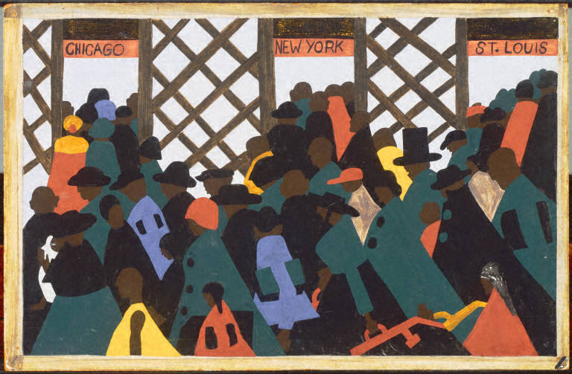

Jacob Lawrence

The Migration Series, Panel no. 1: During World War I there was a Great Migration North by Southern African Americans, 1941

Casein tempera on hardboard

12 x 18 inches (30.48 x 45.72 cm)

The Philips Collection Washington, DC

© ARS New York

<http://www.phillipscollection.org/index.aspx>